Pass for level 25: GHF6X7YwACaYYssHVY05cFq83hRktl4c

Step 1: Login to natas 25

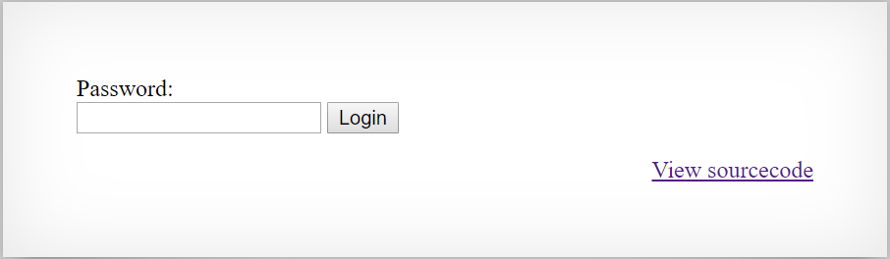

Step 2: View source code

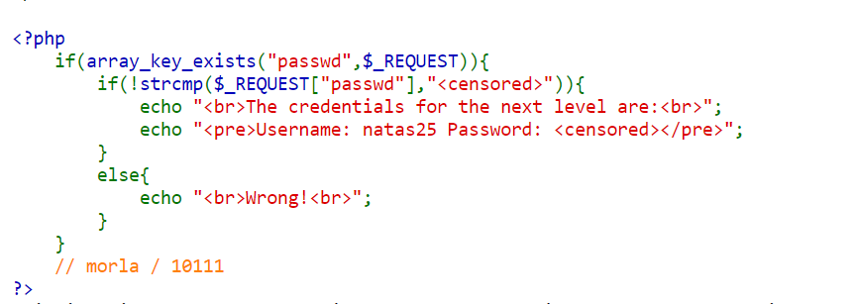

Step 3: Searching for vulnerabilities in PHP strcmp() function.

The idea is to compare two different types it will receive NULL.

Like strcmp(array(),number)

First try to insert Array() to the input:

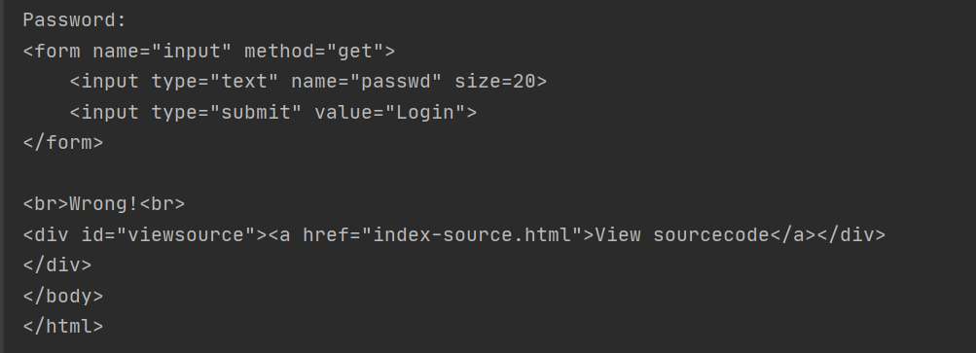

Second try(with help from google) I changed the passwd to an array 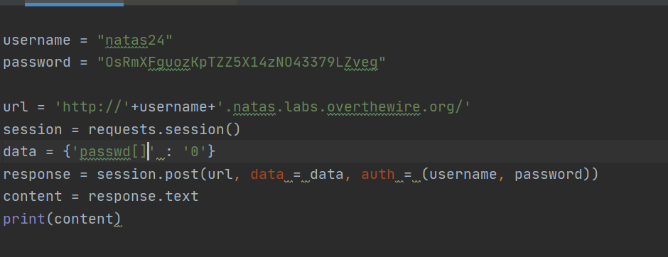

Then the results changed to :

